Class of ‘82

40 Year Reunion Registration

All event details and updates will be posted on www.losalamos82.com.

Please complete form online and email to lahstoppers82@gmail.com. Make make payments as described below.

Name:
Guest:
Address:
Cell Phone: |  | Email:

I will be attending the following event(s) on Friday, September 16th. Check the following:
Golf Tournament, add number of participants _________ (fees not included)
Homecoming Parade
Pre Game Mixer and Reunion Registration – Elks Lodge
Hilltopper Football Game
Victory Party – Elks Lodge

I will be attending the following event(s) on Saturday, September 17th. Check the following:
LAHS Tour
OR
Rendija Hike
Dinner Party – Cottonwood on the Greens

Friday Number of Guests Attending |  | X | $65 per guest =
Saturday Number of Guests Attending |  | X | $75 per guest =
OR
Friday & Saturday Number of Guests Attending |  | X | $105 per guest =
Total Amount Due =

Payment Information:
1) Send check payable to “David Newcom” with “LAHS Class of ’82 Reunion” on memo line and mail to:
LAHS Class of ’82 Reunion Committee
2818 N 2225 East
Layton, UT 84040

OR

2) Pay using Venmo – address @LAHS82Rules and the last four digits of David’s phone number "2533"

Other Interesting Information:
Did you serve in the military, and if so, which branch?
How many grandchildren do you have?
Is this your first high school reunion?
Any interesting news you’d like to share about yourself?

Choose T-Shirt Size for Class of ’82 Graduates Only

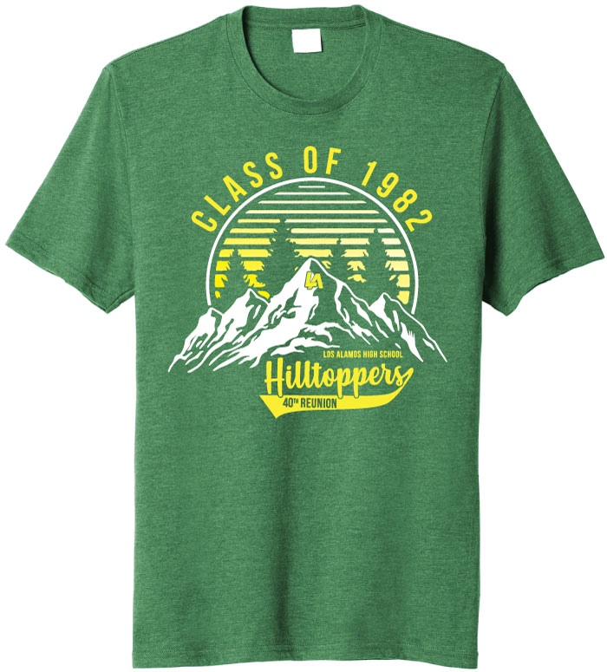

Unisex Adult Sizing
Heather Green | Sizes Small to 3XL | Size:

